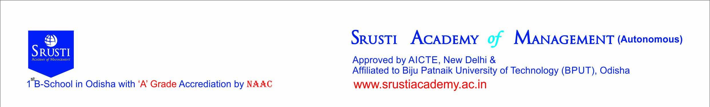
Date :__________________
CLEARANCE CERTIFICATE FORM
By Office
Mr / Ms. _______________________________________________ of 2nd /4th / 6th Semester MBA /MCA / IMBA has an outstanding amount of Rs. ____________________ and 1st / 2nd / 3rd / 4th /5th year dues if any :-
- College dues :_______________
- Hostel dues :________________
Total : ________________

Last deposited amount_____________ Date of last payment ______________ Accounts Section
By Student
I Mr/Ms._______________________ bearing University Registration No. _______________ do hereby undertake that I will deposit my pending dues of Rs. ______________________ on or before dt. _________________ failing which necessary disciplinary action as deemed fit will be initiated.

Students Mobile No_________________ Guardian/Parents Mobile No________________ Signature of Students
Library _______________ Dept HOD __________________

